**Project Design Phase-I**

**Solution Architecture**

|  |  |
| --- | --- |
| Date | 16 October 2022 |
| Team ID | PNT2022TMID28495 |
| Project Name | Deep Learning Fundus Image Analysis for Early Detection of Diabetic Retinopathy |
| Maximum Marks | 4 Marks |

**Solution Architecture:**

Solution architecture is a complex process – with many sub-processes – that bridges the gap between business problems and technology solutions. Its goals are to:

* Find the best tech solution to solve existing business problems.
* Describe the structure, characteristics, behavior, and other aspects of the software to project stakeholders.
* Define features, development phases, and solution requirements.
* Provide specifications according to which the solution is defined, managed, and delivered.

**Technologies needed for Minimum Viable Product deployment**

Software technologies required for the systematic development and deployment of the project are:

* HTML/CSS/JavaScript/bootstrap-Front End Development
* Python
* TensorFlow
* Image processing Basics
* Flask-Backend Development
* Git & GitHub-project Management
* IBM Cloud-Hosting
* IBM Watson-Training the Deep Learning Model

**SOLUTION- ARCHITECTURE DIAGRAM:**

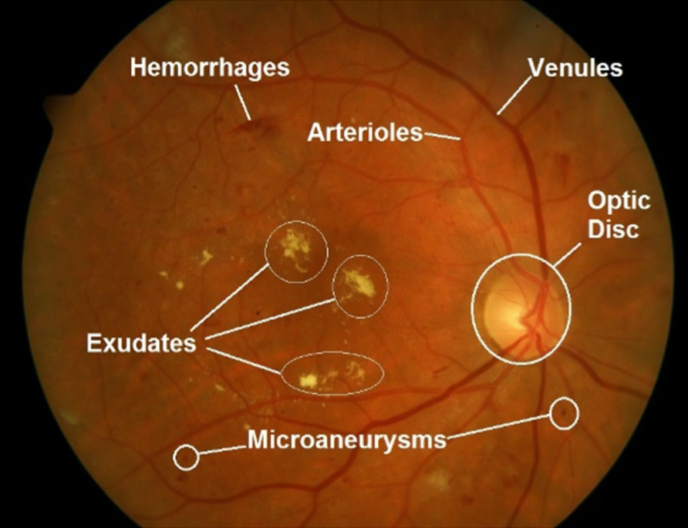

**CONTRAST ENHANCEMENT**

(E-GIF)

(E_GIF)

**PREPROCESSING**

GREY SCALE CONVERSION,NORMALIZATION CONTRAST LIMITED ADAPTIVE HISTOGRAM EQUALIZATION,GAMMA ADJUSTMENTS

TRAINING IMAGES

FEATURE EXTRACTION

DATA AUGMENTATION



TRAINING SAMPLES

UI (WEBPAGE)

TESTING SAMPLES

NETWORK TRAINING

(DRU NET)

DIMENSION REDUCTION

(PCA)

XCEPTION-CNN ARCHITECTURE

CLASSIFICATION

(SYMPTOMS/NONSYMPTOMS)

RETINOPATHY

NORMAL

Figure 1: Architecture and data flow of the voice patient diary sample application

**Reference: <https://aws.amazon.com/blogs/industries/voice-applications-in-clinical-research-powered-by-ai-on-aws-part-1-architecture-and-design-considerations/>**